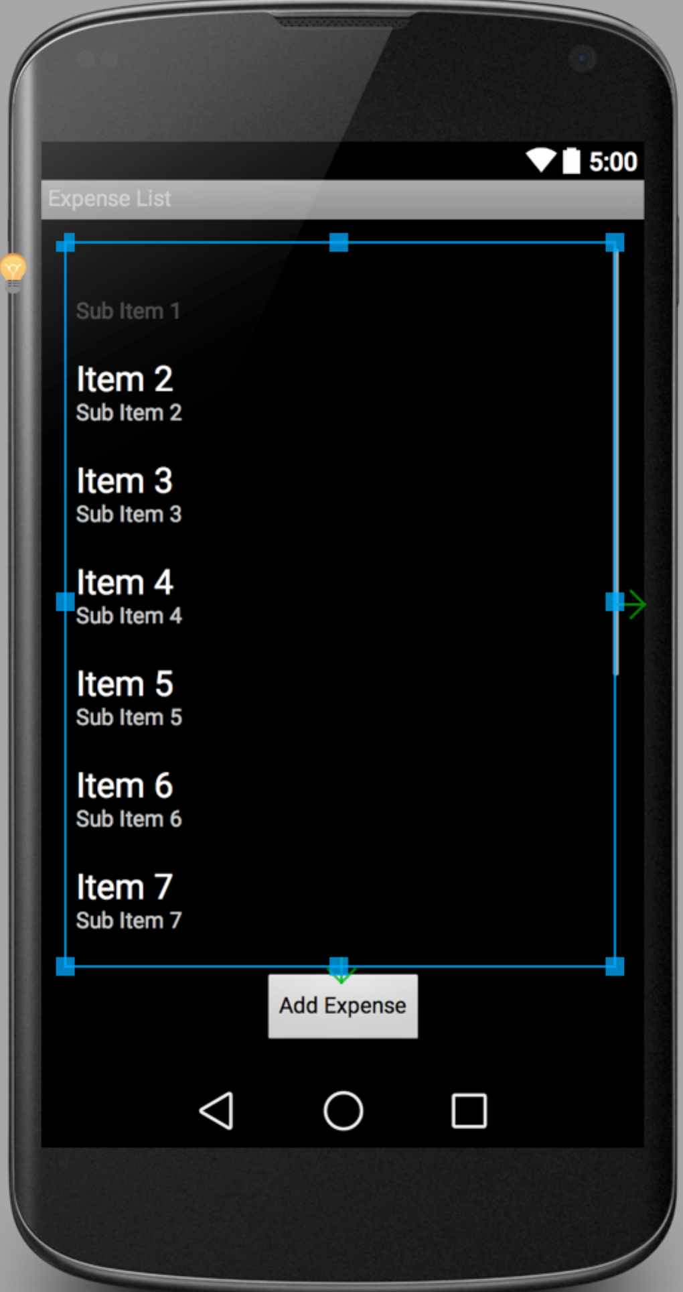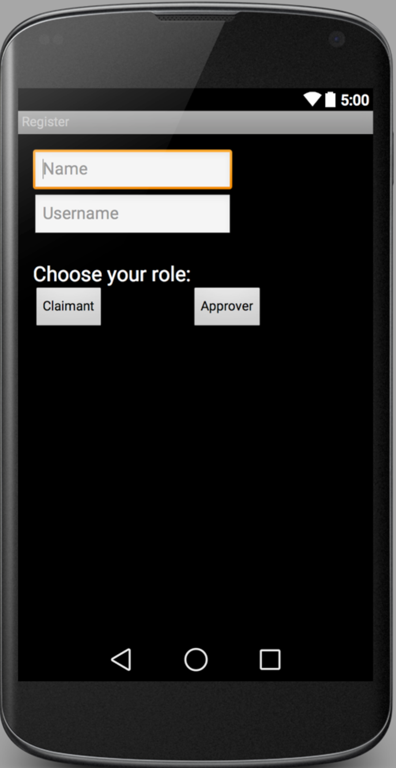

Expense list, claimant can also flag, view, delete, and edit the expenses that are created

After clicking “View/Add Expenses”, clicking “Save” or “ Submit” to finish. Then go back to Claim List Page.

After clicking “Create New Account”

After choosing either “Claimant” or “Approver”, user will go back to main page and login with their username.

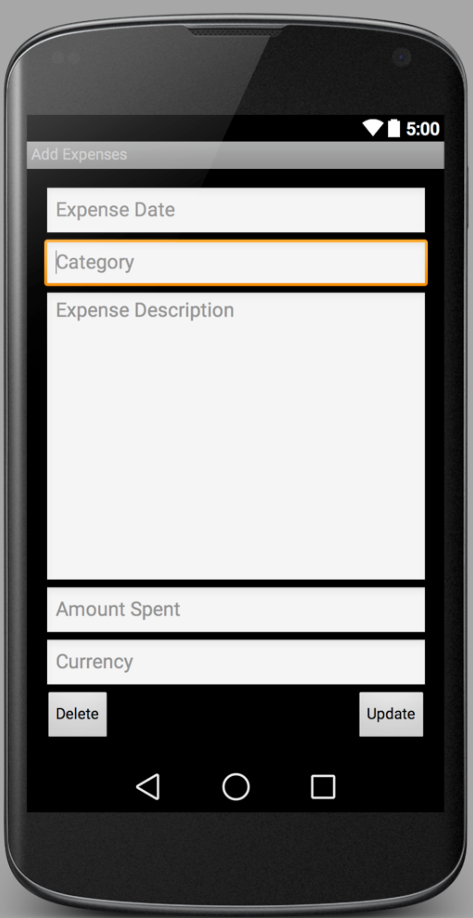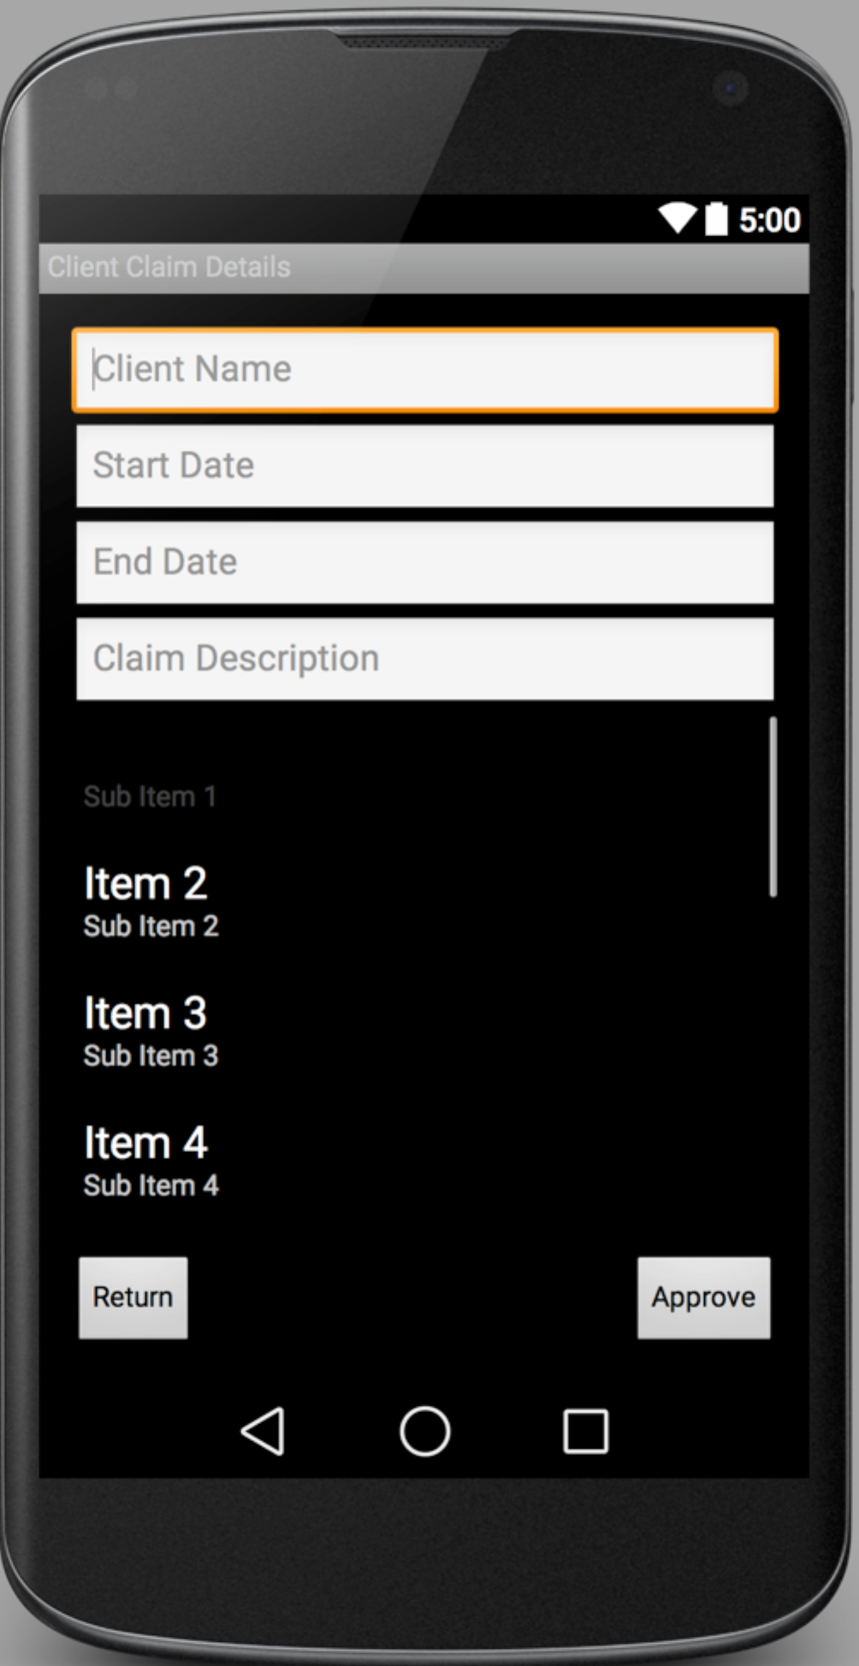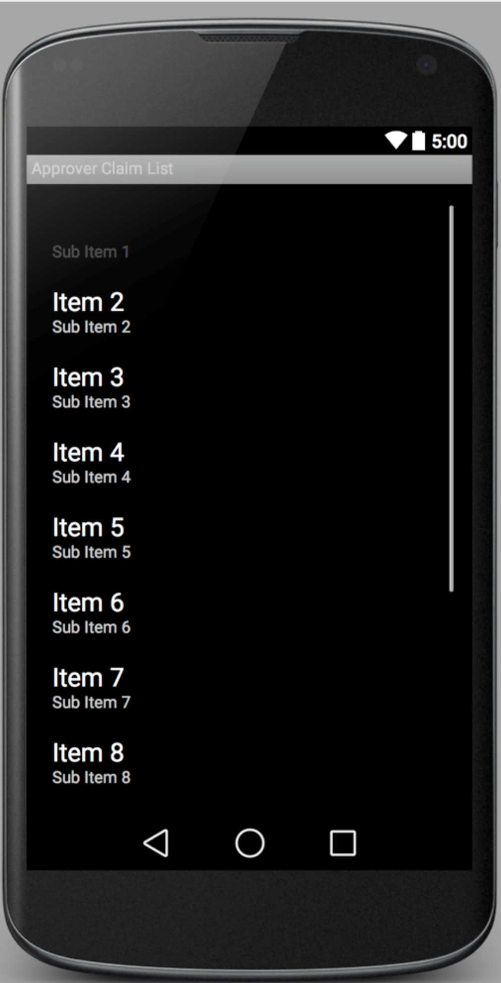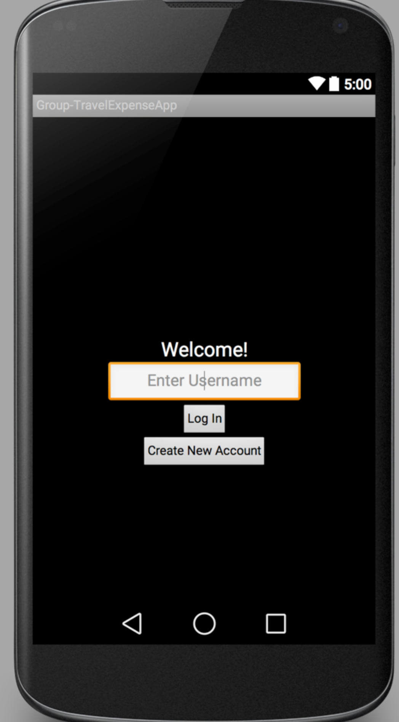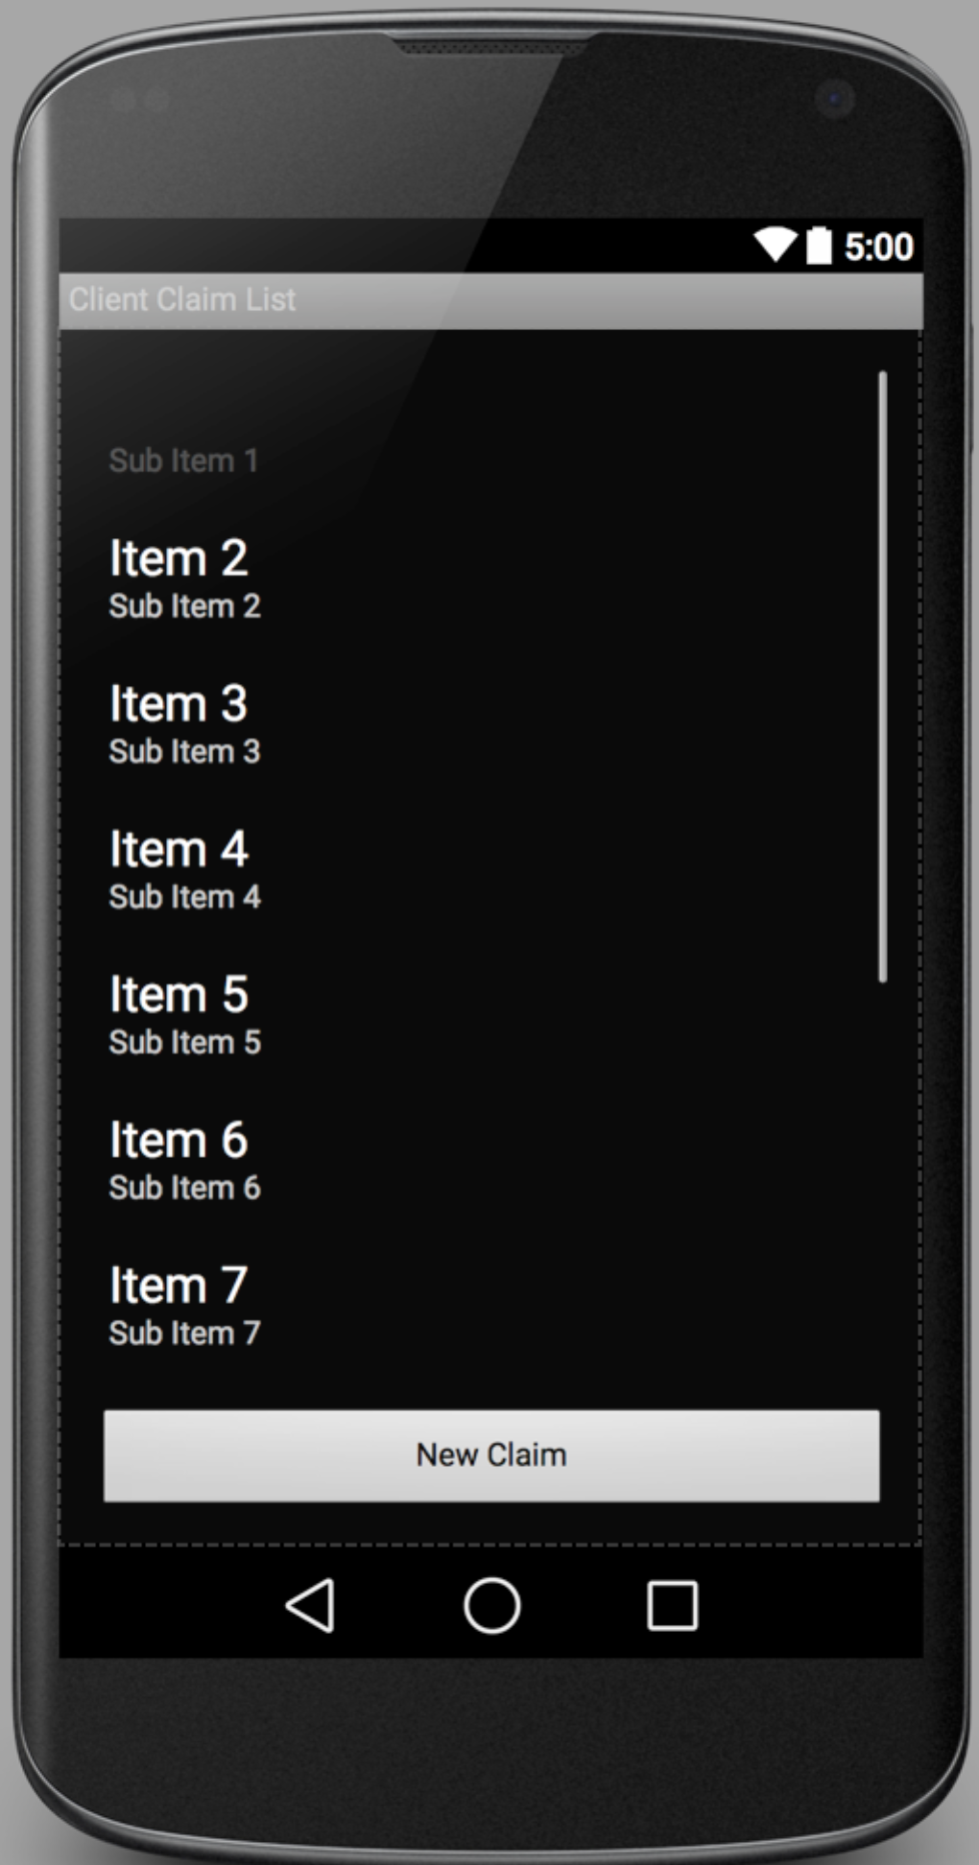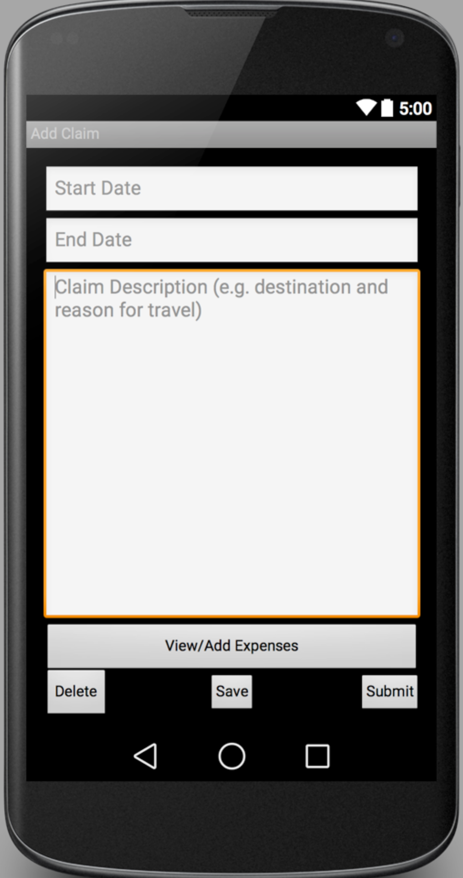

The above claim list, claimant can also tag, delete, view, and edit the claims that are created

After clicking “New Claim”

After checking all the details, clicking “Return” for returned purpose or “Approve” for approval. Then go back to Claimant Claim List.

After login as approver

After login as claimant

After clicking a specific claim item, you will get to view all the details of the specific claim.

After entering all the details, clicking “Update” to finish add one expense item. Then go back to Expense List Page.

After clicking “Add Expense”